ECOSPACE guidelines

Jeroen Steenbeek
Ecopath International Initiative, Spain

Purpose
This document provides guidelines for creating, configuring, and running Ecospace scenarios in the Ecopath with Ecosim (EwE) software. Specifically, this module is intended to support JRC ecosystem modelers in adjusting and re-running the spatial temporal module (Ecospace) of the Mediterranean Ecopath model previously built by JRC.
This document was written using EwE version 6.6 Beta 4, March 2019, and is divided in the following sections:
- Creating a new Ecospace scenario
- Affecting species distributions
- Fishing
- Using externally modelled data
A few generic tips:
- As EwE does not have an undo function, please save often
- Build up and test Ecospace model complexity g, one hypothesis at the time
- Try to achieve spatial patterns through top-down or bottom-up effects first. Especially spatial distributions of primary producers cascade through the food web
- Configure the Ecospace niche model for the most dominant groups first
- Know the limitations of Ecospace

Creating a new Ecospace scenario
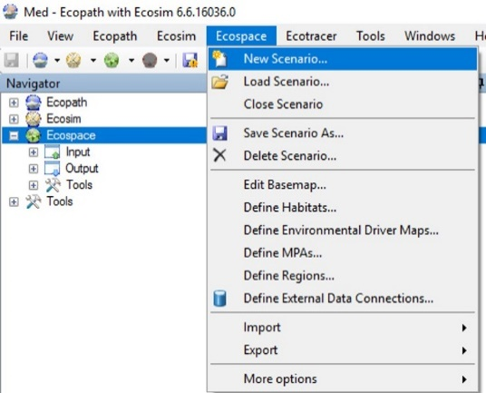
In the EwE software, load the Mediterranean Ecopath model, and load any Ecosim scenario. There is no need to load any time series at this point.
- Select Menu > Ecospace > New scenario… This opens up the “Create Scenario” view

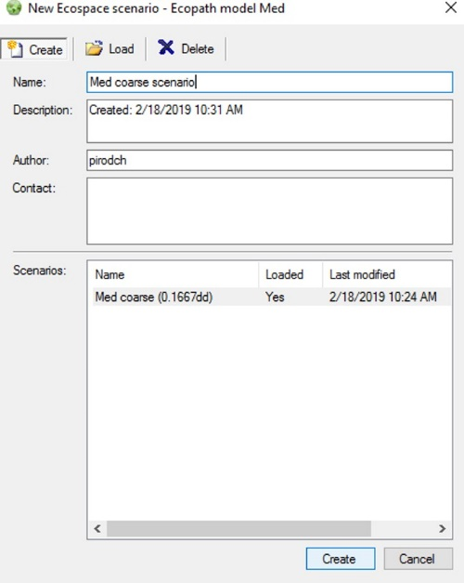
- Describe the new Ecospace scenario and its purpose in the available fields. It is mandatory to enter a name, for instance "Med coarse scenario"; the other fields are optional
Press Create. The new scenario will now be created and loaded in the EwE software.

Note that the “Create Ecospace Scenario” view can also be used to modify and delete existing Ecospace scenarios.

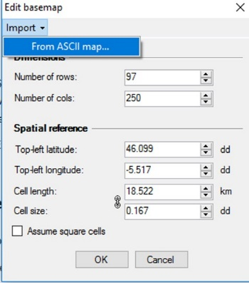
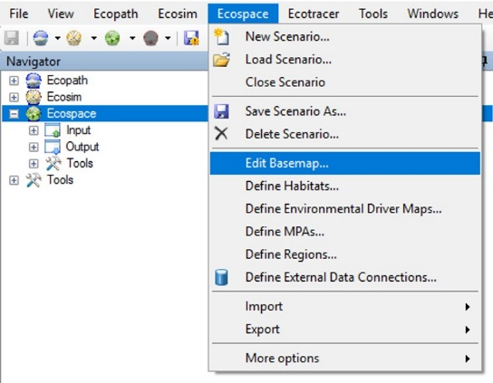
Next, define the spatial extent, cell size, and bathymetry of the new Ecospace scenario:
- Select Menu > Ecospace > Edit Basemap… This opens the “Edit basemap” view. Here, Ecospace offers the option to import the spatial properties and map data from ESRI ASCII map files, the only common GIS data format natively supported by the EwE software.
- Select Import > From ASCII Map…
- Browse to the folder with one of the pre-built ASCII depth maps for the Mediterranean model, Select the map you wish to base a new Ecospace scenario on, and click Open. The ASCII map is being read, and if read correctly, the “Edit Basemap” form shows the spatial extent and cell size read from the ASCII map, and the form will lock up for further editing.
- Uncheck "Assume square cells" to make sure Ecospace takes into account cell tapering at different latitudes
- Press OK. Ecospace will now load the map.
- To View and validate the bathymetry map, go to Navigator > Ecospace > Input > Maps, and click the Depth layer on the right side map layers panel:
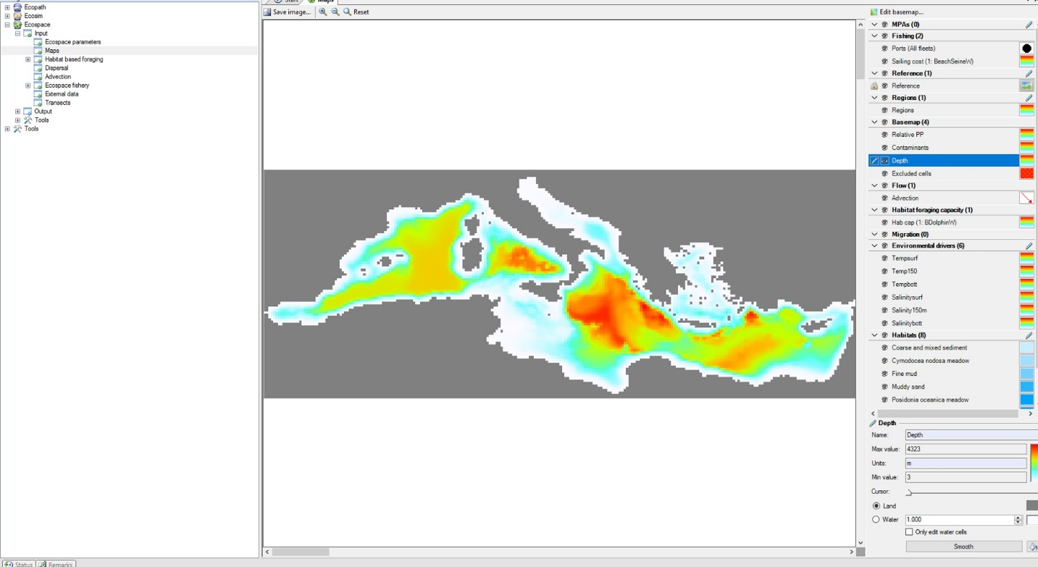
- Save!

Excluding cells
It may be desirable to block specific Ecospace cells from participating in the food web calculations, for instance for regions that fall outside the modelled area but are visible in the rectangular Ecospace base map area. In EwE versions prior to version 6.5, these cells had to be allocated as land. This approach had several drawbacks. As land was reported in water areas, credibility of such adjusted Ecospace scenario maps could be questioned. Additionally, this approach would cause loss of data, as all map layer content for lost water cells would also be lost.
The Excluded Cells layer was added to overcome these drawbacks, excluding cells from ecosystem dynamics without having to alter the layout of land, and without losing any data contained within excluded cells.
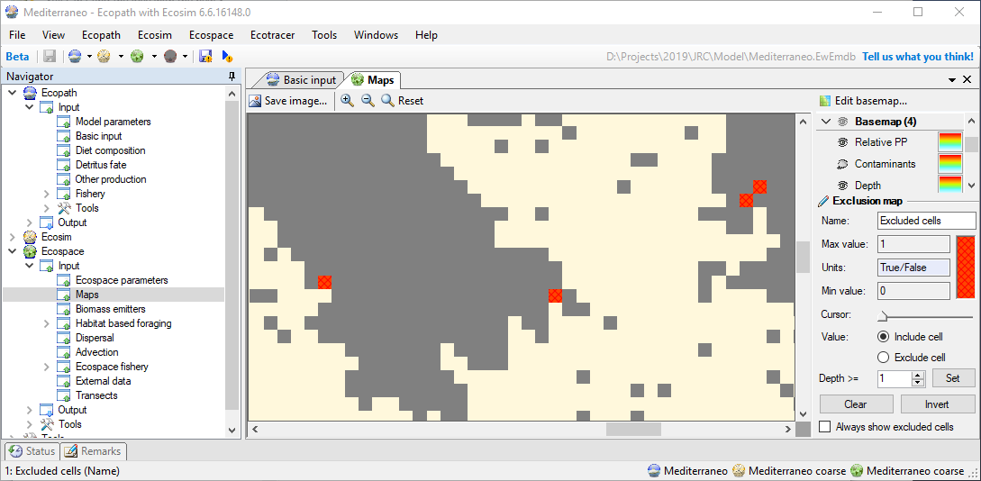
To exclude cells from ecosystem dynamics:
- Go to Navigator > Ecospace > Input > Maps
- Select the “Excluded cells” layer in the layers right-hand side layers overview
- Click and draw on the map to change layer content. The layer editor panel, bottom right, provides several options when editing the excluded cells map.
- Check the “Always show excluded cells” option in the layer editor panel to draw excluded cells in the Ecospace maps (both input and output). Uncheck this option to hide excluded cells from every map view other than when editing the excluded cells layer itself.
- Double-click the layer to import an ASCII map for this layer.
In the JRC Mediterranean model all Ecospace cells that would not receive spatial-temporal driver data were excluded from ecosystem dynamics. This is particularly important when relying on the Relative PP Ecospace layer for driving ecosystem dynamics. Cells that do not receive external data will retain initial values. Default Ecospace Relative PP values of 1 would notably affect the how Relative PP driver data (obtained from the MedERGOM-GETM model) was scaled to the Ecopath baseline values. Excluding these offending cells removed this scaling bias.
A utility was built for this project to identify and exclude land-locked single cells:
- Go to Menu > Tools > Exclude isolated cells. If such cells are found, a prompt will ask for confirmation to proceed before the excluded cells layer is altered. If no such cells are found, no prompt will be shown, and no changes will be made to the excluded cells map.
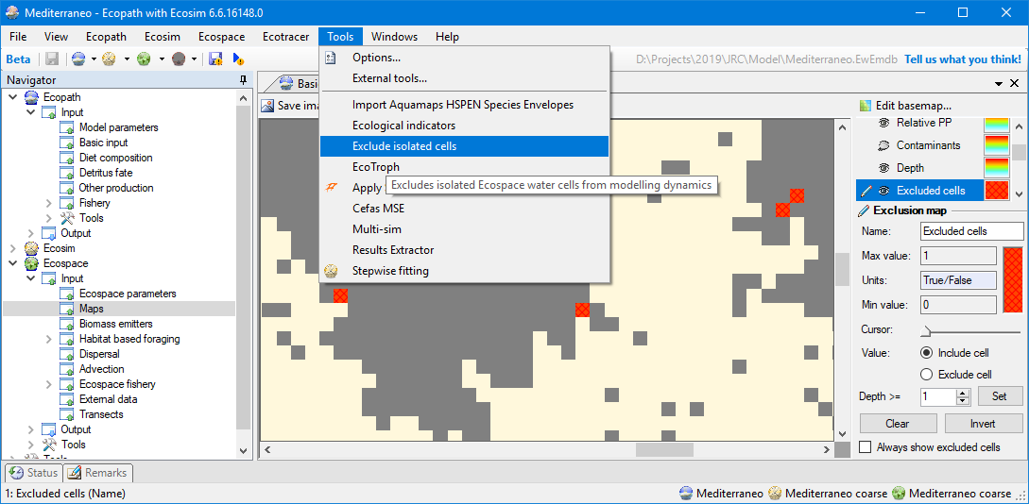

Affecting species distributions
Ecospace contains a species niche model, the habitat foraging capacity model, as detailed in Christensen et al. (2014). This model computes cell foraging suitability from the multiplicative effects of environmental sensitivities and the additive effects of habitat affinity.

Using environmental drivers
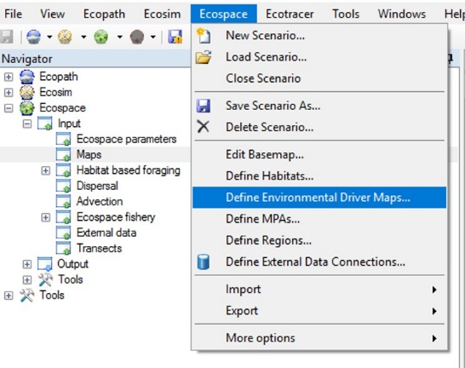
Environmental drivers affect the spatial distribution of those functional groups with specific preferences for, or tolerances to, environmental conditions that may limit their distributions. Besides depth, the Mediterranean model uses environmental drivers to define cell suitability for the functional groups. The production version of the Med-Ecospace contained nine drivers: “Temp surf”, "Temp 150m", "Temp bottom", “Salt surf”, "Salt 150m", "Salt bottom", "Oxy surf”, "Oxy 150m", "Oxy bottom". Any number of drivers can be used to influence a model.
Note that Ecospace is a 2D model and does not explicitly represent the vertical water column. Vertical stratification of the food web is implicitly defined in Ecopath through dietary relationships, and in Ecospace through the use of stratified environmental drivers such as obtained from MedERGOM-GETM for specific depth zones. By applying stratified environmental responses to affect functional groups living at corresponding depth zones, Ecospace implicitly considers vertical stratification.
To define an environmental driver:
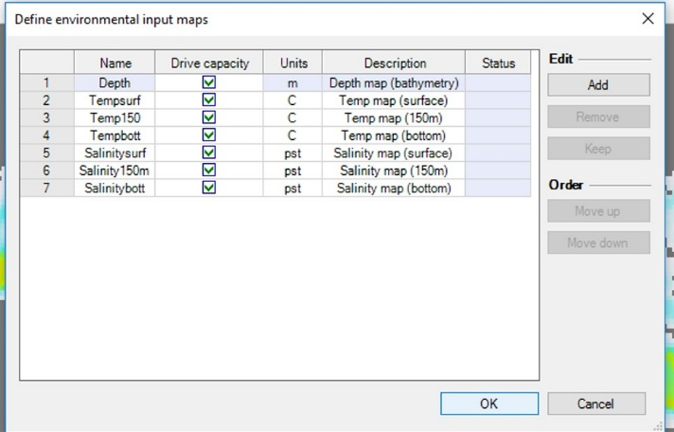
- Select Menu > Ecospace > Define environmental drivers…
- Press Add to define an environmental driver
- Enter a descriptive name by which the driver will be shown in the EwE user interface. Other fields are optional, but entering units and a description is recommended
- Click OK. Ecospace will update the list of available environmental drivers and will close.
Note that the Depth layer is always included as an environmental driver, and that, for obvious reasons, this layer cannot be renamed or deleted.
Ecospace will create any new drivers and will close. Note that one can also use the ‘Define environmental drivers’ interface to rename drivers, change units or descriptions, or delete drivers.
Newly defined drivers will need a map showing the spatial distribution of that driver at model startup. To populate a map of an environmental driver, do the following:
- Load the Ecospace scenario if not loaded, and go to the Maps view
- From the layers overview at the right, double click the environmental driver layer to enter map content for. This brings up the “Edit Layer” view, where one can view and edit the layer properties, data, and display style.
- Go to the tab named “Data”
- Choose Import > From ASCII grid…
- Browse to the map file, select it, and click Open to import the data.
- Save when done
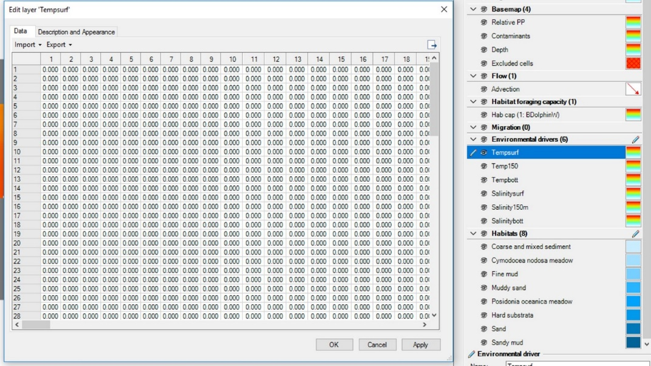
The environmental drivers are now defined, they have spatial distributions across the modelled area, but they do not affect Ecospace yet through the Habitat Foraging Capacity model (or “Capacity Model”, see Christensen et al., 2014). As a guideline, keep the following in mind:
- As it is easy to over-constrain the Ecospace model, reducing the foraging arena to the point of depriving food web components of food, it is recommended to use environmental forcing to a minimum to obtain expected distributions and behavior. Bottom-up or to-down environmental impacts cascade through the food web
- Beware of auto-correlation between environmental drivers; temperature, salinity and oxygen concentrations may be an effect of depth.
To make an environmental driver effective for a specific functional group, do the following:
- Define an environmental response function in Ecosim or Ecospace (both models share the same functional response functions). When editing response functions please be aware that their curve is described through 1200 X-axis values that represent the sensitive driver variable range with minimum driver tolerance at X=1 and maximum driver tolerance at X=1200. The Y axis expresses the magnitude of the mediated effect [0, 1] for each corresponding driver value.
Response functions can be defined and populated in different ways:
- Manually define a function, and sketch its contour in the EwE user interface
- Manually define a function, and copy/paste its contour from external analysis (R, Excel, etc.)
- Manually define a function, and define its contour through the Change Shape interface
- Import functional responses directly from AquaMaps (Menu > Tools > Import Aquamaps HSPEN Species Envelopes; usage instructions for this plug-in are provided with the EwE installation)
- Go to Navigator > Ecospace > Habitat based foraging > Group capacity model to ensure that desired functional groups are configured to use environmental responses
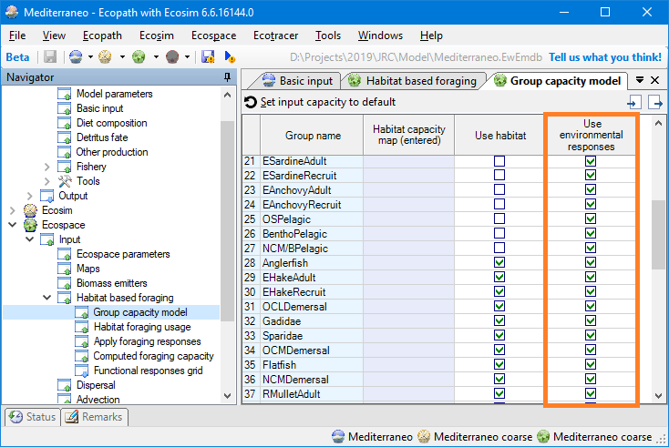

- Apply environmental responses for individual functional groups in Navigator > Ecospace > Input > Apply foraging responses
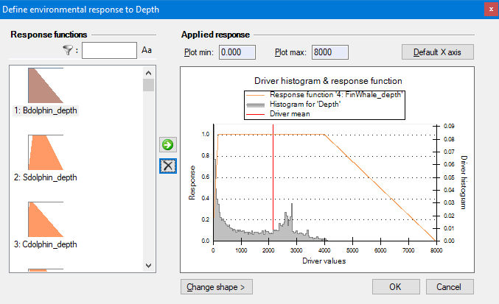

Using habitats
Ecospace uses habitats to represent and affect the distribution of functional groups with affinity for specific types of substrate. Users are free to define as many habitats as needed, where each habitat should correspond to a specific substrate, and its corresponding map layer expresses the fraction of cell area coverage by that type of substrate [0, 1].
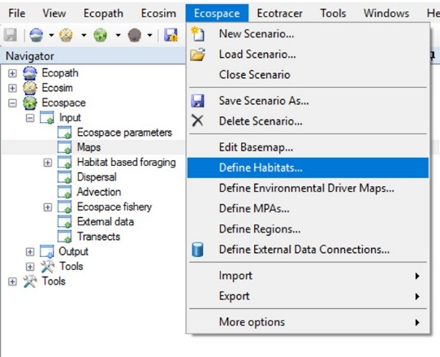
Define or remove habitats as follows:
- Select Menu > Ecospace > Define habitats…
- Click Add to define new habitats
- Enter a name that characterizes the habitat
- Click OK. The habitats will now be created and Ecospace will close and reload.
To populate the map each habitat:
- Go to the Ecospace maps view
- Double-click a habitat layer in the right-hand layers overview
- In the Data tab, import an ESRI ASCII map as explained above.
To make habitats affect the distributions of specific functional groups:
- Go to Navigator > Ecospace > Habitat based foraging > Group capacity model to ensure that relevant functional groups are configured to use habitats
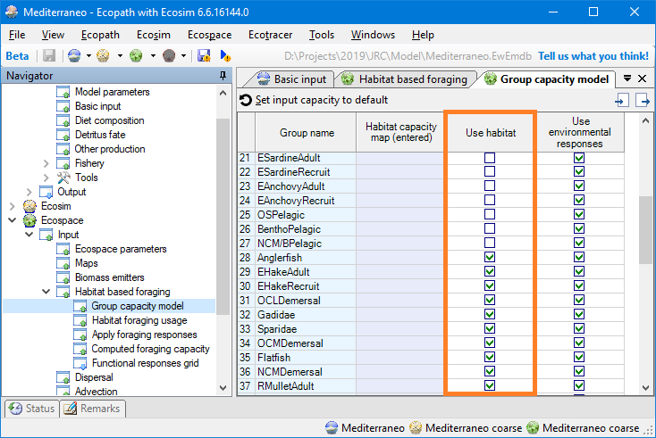
- Go to Navigator > Ecospace > Input > Habitat base foraging > Habitat forage usage to configure habitat affinities for the food web.
- In a group row, enter the suitability of each habitat to that group as a value in the range of [0, 1]. Note that the row total does NOT need to sum to one
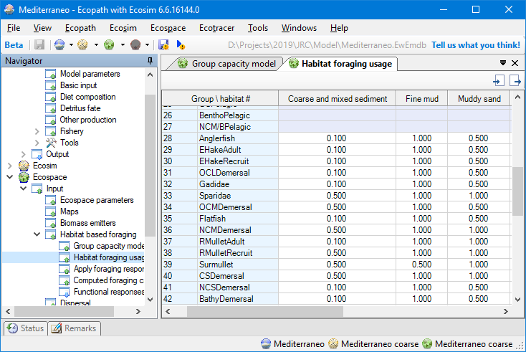
- Save

Validating the niche model configuration
To be able to validate the Ecospace niche model configuration we developed a new Ecospace view called “Computed foraging capacity”. Here, one can view the habitat foraging capacity as computed by Ecospace, based on applied environmental tolerances and habitat preferences.
- Go to Navigator > Ecospace > Input > Habitat base foraging > Computed foraging capacity to show this new view. In the right-hand layer panel one can select the functional groups for which to view computed [habitat foraging] capacity, and view and edit environmental driver maps, habitat maps, the depth map, and the excluded cells map.
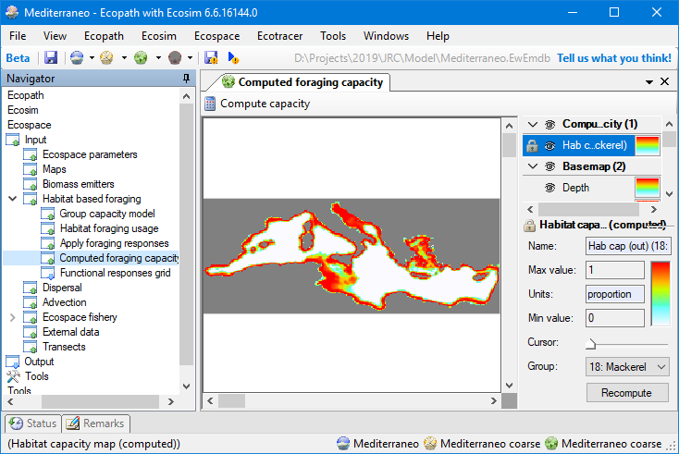
- Double-click any layer to view and edit the data in the layer. Note that the Computed Capacity layer content cannot be edited.
- Click Compute capacity to recalculate Computed Capacity for all groups. Note that capacity is not recomputed automatically while parameterizing Ecospace, as this can be processor intensive, and thus negatively affect the responsiveness of the EwE user interface. When Ecospace is ran, habitat foraging capacity is recalculated for every time step.

Marine protection
Marine protected areas impose fishing restrictions on a per-fleet, per-month basis.
To define MPAs:
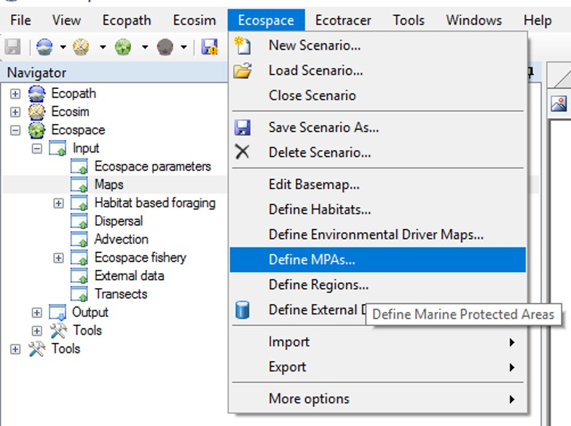
- Go to Menu > Ecospace > Define MPAs…
- Click Add to define a new MPA
- Enter a name
- Click OK

To populate MPA maps:
- Go to Navigator > Ecospace > Input > Maps
- Double-click a MPA layer
- In the Data tab, import an ASCII map. Note that since EwE version 6.4 MPAs can overlap. MPAs layers require integer values, one map per MPA, where non-zero identifies that the MPA fully occupy an Ecospace cell.
To configure when the MPA is open or closed to fishing:
- Go to Navigator > Ecospace > Input > Ecospace fishery > Marine Protected Areas
- Check all months that the MPA is enforced, and thus imposes fisheries limitations
To configure which fleets each MPA applies to:
- Go to Navigator > Ecospace > Input > Ecospace fishery > MPA enforcement
- Check all fleets that the MPA prohibits from entering

Fishing
Ecospace inherits nominal fishing effort from the underlying Ecopath and Ecosim models. Ecospace spatially redistributes fishing effort as a tradeoff between the incurred costs versus potential yields of landings. Effort distributions are thus an output of the Ecospace model. To influence effort distributions one can turn to the fishing cost layer – a per-fleet spatial distribution of scalar values that acts as a multiplier to the fleets’ CPUE as entered in Ecopath. Traditionally, the fishing cost layer is used as a proxy for distance from port or distance from coast, but modelers are free to deploy this layer as an inversion of historical effort patterns, or to try to convince Ecospace effort to stay within specific zones.
To define fishing costs:
- Go to Navigator > Ecospace > Input > Maps
- Select the fishing cost layer
- At the layer edit panel (bottom right), select a fleet to enter fishing cost for
- Double-click the fishing cost layer
- Import an ASCII map in the Data tab

Using the Spatial Temporal Framework
The spatial temporal framework is a plug-in to the EwE 6 software, built with the sole purpose to dynamically insert (time varying) spatial data that is external to the EwE model into Ecospace map layers (Steenbeek et al., 2013).
The framework integrates with the EwE6 user interface in several locations as shown below.
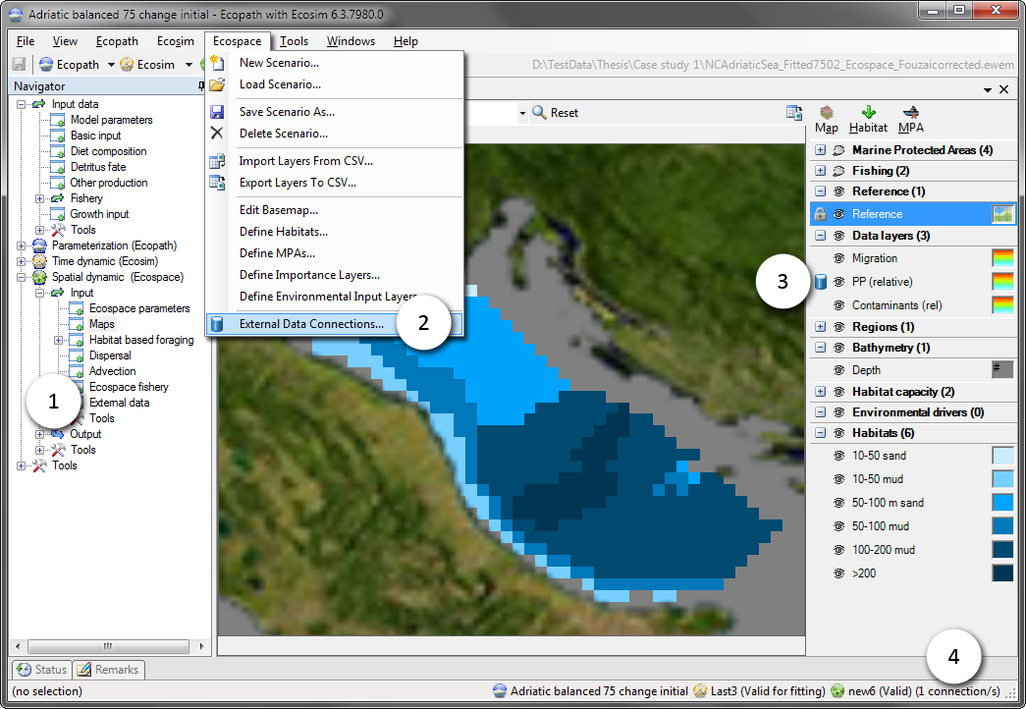
The EwE6 user interface, with indications to the presence of the external spatial data facilities: (1) an item in the EwE navigation tree, (2) a configuration option in the Ecospace menu, (3) a blue database icon beside each map layer in the Ecospace map interface to indicate this layer is connected to external data, and (4) a the number of external data connections summarized in the EwE status bar.

Connections
A ‘connection’ is the link between an Ecospace map layer and a repository of maps (or time series of maps) that are not stored within the EwE model. Connections are defined by the EwE user, and can be shared across computer systems.
Connections are managed from the central “Define external spatial temporal connections interface“ view which is accessible from several locations throughout Ecospace. Here, users can create and delete connections of different types, manage in which file the connections are stored on the local machine, export connections and their data for sharing with other users, and control whether the framework is allowed to dedicate background processing time to index the spatial and temporal overlap of external data with the current Ecospace scenario.
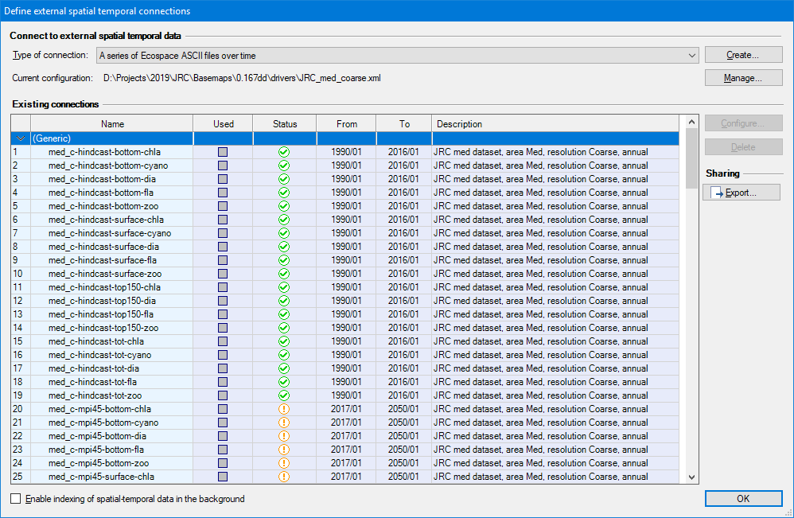
Existing connections are briefly summarized. The Used column states if the connection is actually applied to one or more Ecospace layers. The Status column uses icons to explain whether the connection has errors ( ), has only partial spatial overlap with the modelled area ( ), or entirely covers the modelled area ( ). The warning icon is also used to notify that data compatibility has not been assessed yet, which can be done by enabling indexing or by running Ecospace, in case each used connection is automatically validated.
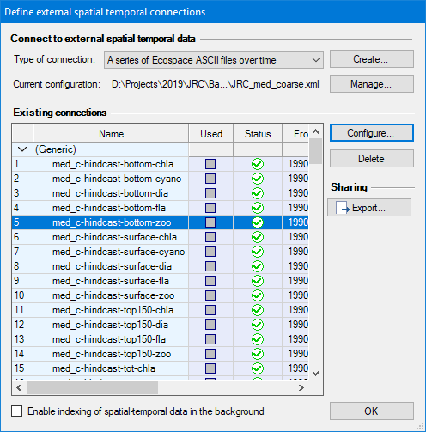
To define a new connection:
- Go to Menu > Ecospace > Define external data connections…
- Select the type of connection to create. At time of writing, four file-based connection types are supported: (1) a time series of ASCII files which must be prepared to match the spatial extent and cell size of a dedicated Ecospace scenario; (2) a time series of spatial files which will be made fit for inclusion in Ecospace by the DotSpatial / GDAL GIS engine encapsulated in the spatial temporal data framework; (3) a file with X,Y,Z,T time series values provided in CSV file format, where (X,Y) coordinates can either indicate (column, row) or (longitude, latitude); and (4) a single spatial file.
- Press Create…. A new connection is defined, and the “Configure external data connection view” opens up to allow its content to be modified.

The configuration process of file-based connections is straight forward:
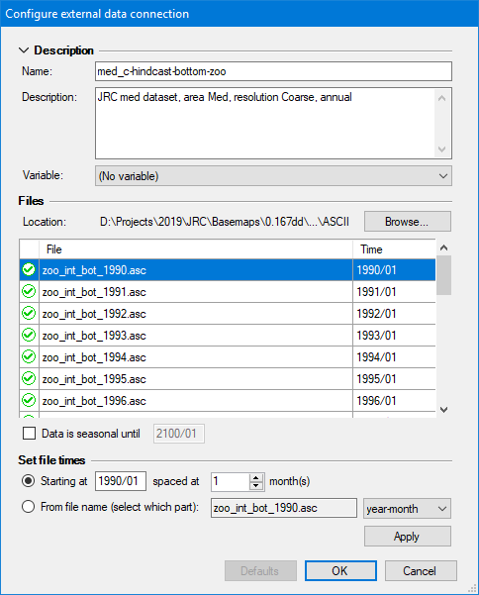
- Enter a name that identifies its content, keeping in mind that you may have a large number of connections to sift through. To illustrate, this Mediterranean modelling exercise featured 150 different connections per scenario.
- Enter a description to state data source, spatial and temporal resolution, data pedigree, and other details, considering one may have many connections to manage.
- Optionally, select the Ecospace variable the connection is limited to. This does NOT assign the connection; it only limits where this connection is available in the EwE user interface.
- Press Browse to select which files belong to the connection browse to the folder where the files reside, and select and insert the desired files. The files list will populate in response. Note that each file represents a map in time. times can be entered by hand, or can be set automatically, either by entering a start date (year/month) and monthly interval, or by reading the time step from a fixed position in the file names. Seasonal data rotates the first year of data until the indicated end date.
- Press OK

Assigning external data to Ecospace
To make external connections operational in Ecospace, do the following:
- Go to Navigator > Ecospace > Input > External data… The External data view opens up, and displays all Ecospace map layers that can receive external data. The toolbar offers options to limit the number of layers on display, with filters by layer type, and only viewing layers with active connections. The external data interface also shows a time line that reflects the temporal overlap of external data with the Ecospace scenario.
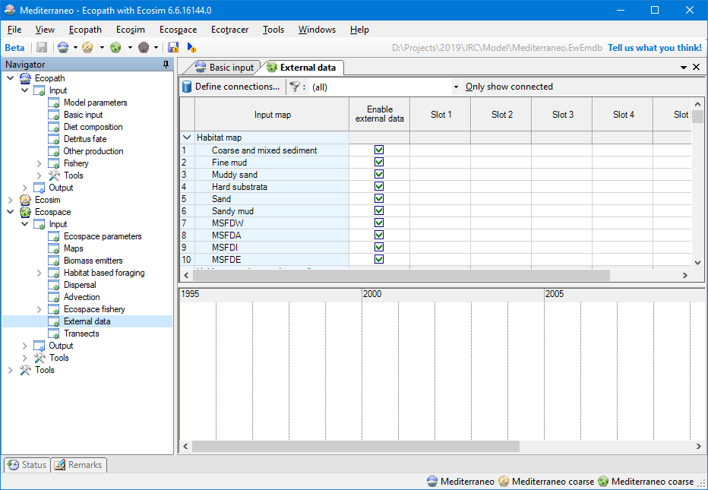
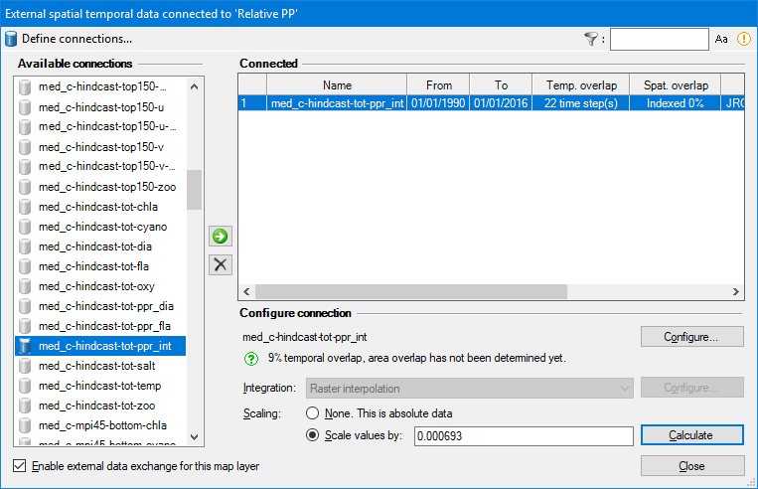
Every map layer has up to six slots for assigning connections. To assign external data to a layer:
- Click the first available slot in the layer that you wish to assign external data to. This opens up the Assign connection interface
- Select a connection from the list of available connections
- Click the use button ( ) to assign the connection. A configuration panel opens with additional options. Available options depend on the type of connection that was selected, and the type of Ecospace layer the connection is applied to. Some Ecospace layers may require data to be scaled, for instance, and for those layers you will need to provide a scalar. The configuration panel also summaries compatibility of assigned external data with the current Ecospace scenario.
- Click Configure to review or change the configuration of the connection (as explained above).
- Select an Integration method if applicable, which are geospatial macros that convert data to the desired Ecospace layer needs.
- Enter a scaling method if applicable
- Enter a scaling factor, which can be left at default 1 if data in the Ecospace scenario is the same as the first month of external data.
- Calculate the scaling factor to scale the first year of external data scales to an Ecopath base value (this is highly recommended when driving the Relative PP layer, for instance).
- Press Close to make the external data connection stick, and save the model.
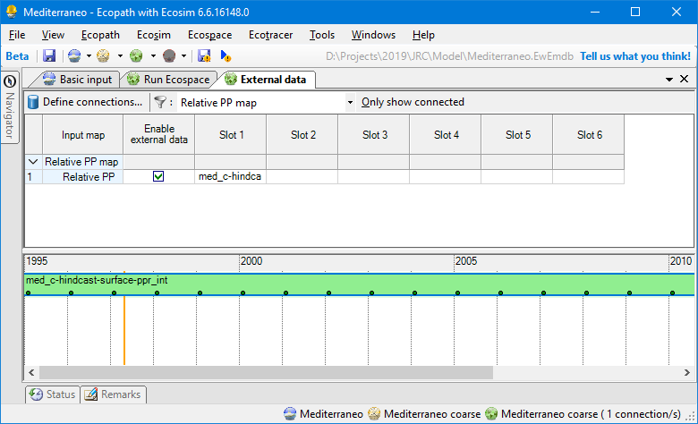
External data assigned to drive the content of the Ecospace “Relative PP” layer

Running Ecospace with external data
When Ecospace is executed as normal, the EwE status panel will show a notification every time external data is accessed and whether integration into the intended Ecospace layer was successful. These notifications are also written to an extensive log file, which is written to the same directory where the EwE model is located. This file can be helpful for troubleshooting external data connection issues.
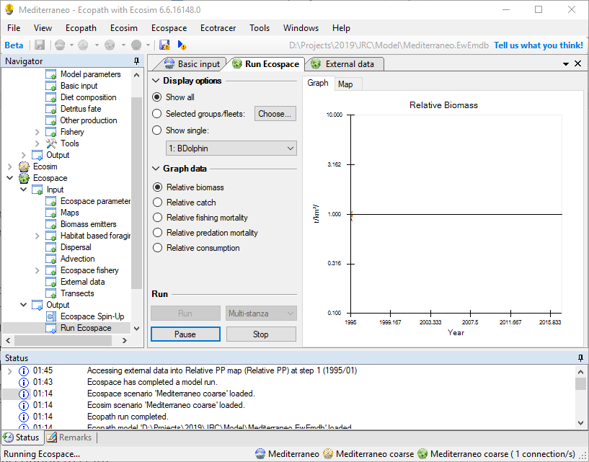
If Ecospace has encountered any issue with external data during a run, it will notify the user that issues were encountered. As the Ecospace run missed some needed external data it should not be trusted, and the status panel and/or spatial log file will provide clues as to why needed spatial data was not found.

Configuration files
All spatial temporal data connection definitions are stored in configuration files. At any given moment, EwE operates on only one configuration file that defines available external data connections. This central storage allows external connections to be reused between Ecospace modelling exercises, and provides a means to organize how much data is visible to a specific modelling exercise.
Configuration files are managed in Menu > Tools > Options > External data… Here, one can create or delete configuration files (in .xml format), add an existing configuration file to EwE, and set the active configuration file.
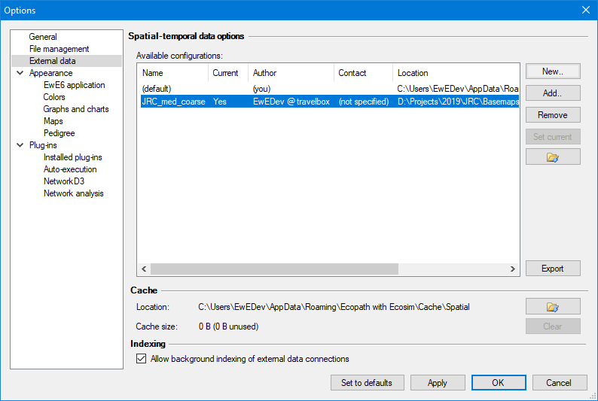
Once a connection is applied to an Ecospace layer, the definition of the connection is stored within Ecospace, while the data remains outside the model.
It is advisable to use separate configuration files for different models, as the number of external spatial temporal data connections can become overwhelming.

Sharing definitions external data with other computers or users
The export external spatial data interface, which can be launched from all locations in the EwE user interface where external data connections are managed, creates new configuration files from selected external data connection definitions, and optionally their data. All exported data is placed in a user-selected folder.
To share external data connected to your model with another computer or user:
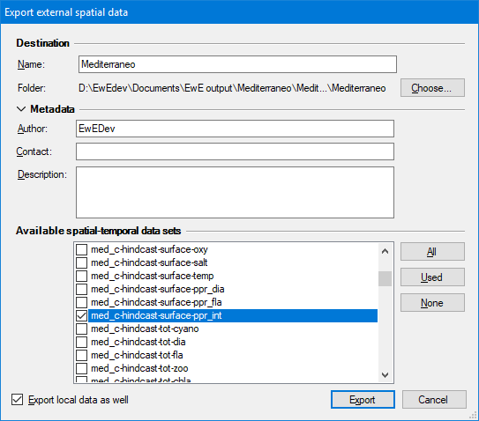
- Open the export external spatial data view, for instance through Menu > Tools > Options > External data > Export
- Enter a descriptive file name (such as “External data Med 0.01667dd”)
- Select Choose to browse to the a location where the exported data can be placed
- Select which connections to export. The “Used” button selects all connections assigned in Ecospace; the “All” button selects all available connections as defined the current configuration file.
- Check “Export local data as well”
- Click Export. Please be patient, this may take a while.
Once the export process is complete, share the data as follows:
- Give the entire exported folder with your model to another modeler. One can also place the exported folder on a shared network drive
To incorporate shared data into EwE:
- Go to Tools > Options > External data
- Click Add
- Browse to the shared configuration file
- Press Open and the configuration file will be added to EwE
- Press “Set Current” to make this the active configuration file
- Load Ecospace. When an Ecospace scenario is loaded, the spatial temporal data framework automatically resolves conflicts in external data connections against the current configuration file.

